Overvoltage Protection Box

8-13-2022

**Schematic**

The box protects the LMP7221 op-amps from accidental over-voltage. They are operated at ±2.5V, but their maximum rating is ±3V (6 V total). When the input equals 3V (or greater) the zeners (Z1, Z2) turn on hard enough to trigger the silicon controlled rectifiers SCR 1 and SCR2. This shorts the output (note the forward voltage of the SCR is 0.8V) blowing the appropriate fuse. Even though the fuse takes ~0.1 s to blow, the SCR protects the output immediately. Because of the small difference between the operating voltage and the maximum voltage, the Zener diodes are operated close to avalanche, taking 9 mA at 2.5 V input. This generates noise and the inductors and high value capacitors remove this noise.

**Operation**

The box input is connected to the controller via a 7 wire cable terminated in DIN plugs. The output is connected to the 32 channel box via a second cable. DO NOT connect the 32 channel box till you have checked the controller voltages (see below)

Note the test points are before the fuses – if you suspect a fuse is blown you will have to remove it and test with a meter. BEFORE you connect the 32 channel box, turn on the controller and measure the voltages at all 4 test points (the instrument case is ground). If a fuse does blow, check the input voltage associated with it. If it is normal, then the SCR could have been triggered by a voltage spike, so its OK to replace the fuse. If not, send the controller back for repair!

Here is the internal layout:

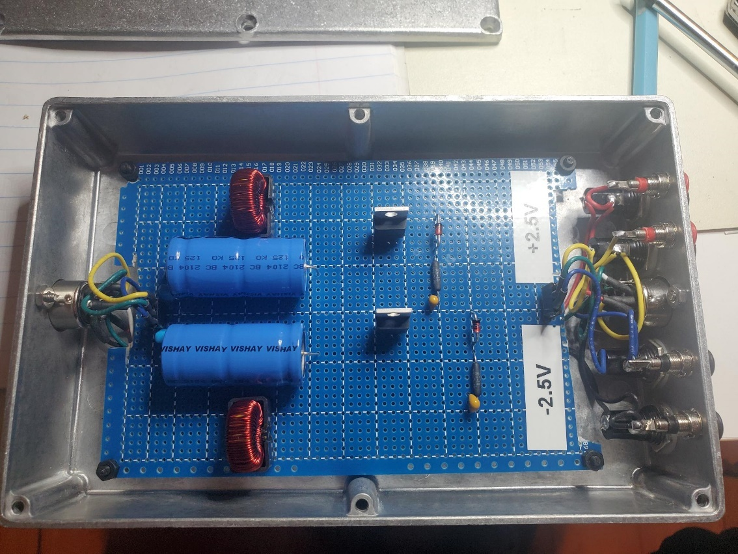

And here is a parts list:

|  |  |  |
| --- | --- | --- |
| Part | Manufacturer Designation | Link |
| Zener, 2.7V | Vishay BZX85C2V7-TAP | [BZX85C2V7-TAP](https://www.mouser.com/ProductDetail/Vishay-Semiconductors/BZX85C2V7-TAP?qs=yIvl1B2wDi6nrjqtkvXm%2Fg%3D%3D) |
| SCR | Littlefuse S6025LTP | [S6025LTP](https://www.mouser.com/ProductDetail/Littelfuse/S6025LTP?qs=bElAnHi1MbM0NVYYwzFGzQ%3D%3D) |
| Fuses | 5x20mm 0.5A fastblow |  |
| Inductors | Pulse Electronics PE-53146NL 330 uH | [PE-53146NL](https://www.mouser.com/ProductDetail/Pulse-Electronics/PE-53146NL?qs=sGAEpiMZZMukHu%252BjC5l7YXc8Ucj8XMl4zs3u5huIxmc%3D) |
| 10,000uF Capacitor | Vishay MAL212515103E3 | [MAL212515103E3](https://www.mouser.com/ProductDetail/Vishay-BC-Components/MAL212515103E3?qs=sGAEpiMZZMukHu%252BjC5l7YWzTb9qNi0OV6A1nc9iuOFY%3D) |
| 22uF Capacitor | Murata RDEC71H226MWK1H03B | [RDEC71H226MWK1H03B](https://www.mouser.com/ProductDetail/Murata-Electronics/RDEC71H226MWK1H03B?qs=sGAEpiMZZMukHu%252BjC5l7YZFl0a7NTZflys2KqucmpT8%3D) |